Friday (5/29)

**//-//-//-//-//-//- //-//-//-//-//-//- //-//-//-//-//-//- //-//-//-//-//-//- //-//-//-**

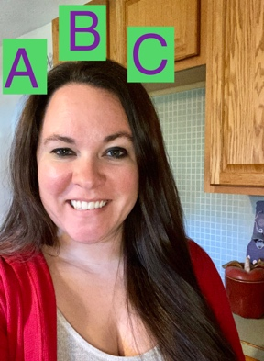

Literacy with Mrs. Acosta

* Story time! The Very Lonely Firefly-By Eric Carle: [Click Here](https://www.youtube.com/results?sp=mAEB&search_query=eric+carle+the+very+lonely+firefly)
* Jack Hartman-Letter V song: [Click Here](https://www.youtube.com/watch?v=yZjEtwr8Q4o)
* Practice writing these V words: Vacuum, violet, viper
* What am I thinking of? 1. It starts with the letter V. 2. It is used to clean your house. 3. It is kind of noisy when turned on. What am I? (Vacuum)

Math with Miss Geary

* + Let’s practice counting! [Click here.](https://youtu.be/DR-cfDsHCGA)
  + [Click here](https://youtu.be/QyK4aqld7Qc) to count different objects. Practice this at home! Go outside and count how many birds you might see!
  + It’s going to be a hot one outside today! Let’s play a game and make ice cream cones! [Click here.](https://www.abcya.com/games/make_an_ice_cream)

Explore with Mrs. Abdo

* + Friday Fun Day
  + Go outside and take a walk with your family.
  + See how many shapes/colors you find on your walk. Keep track and tell your teacher when you talk to her next week.
  + While you are outside see if you can do these animal moves: bear, rabbit, snake, fish, horse, elephant

*Use below if you have NO technology *

Friday (5/29)

**//-//-//-//-//-//- //-//-//-//-//-//- //-//-//-//-//-//- //-//-//-//-//-//- //-//-//-**

Literacy with Mrs. Acosta

* Story time! Get something good to read and read with a family member
* Sing the alphabet song. When you get to V hop like a frog from your kitchen to your living room
* Practice writing these V words: Vacuumm violet, viper
* What am I thinking of? 1. It starts with the letter V. 2. It is used to clean your house. 3. It is kind of noisy when turned on. What am I? (Vacuum)

Math with Miss Geary

* + Practice singing and counting to at least 10! If your child can count higher, encourage them to do so.
  + Practice counting objects out of order at home. Then ask your child to put these objects in a line!
  + Play a game at home! This could include a skillful game on a tablet or a fun board game at home!

Explore with Mrs. Abdo

* + Friday Fun Day
  + Go outside and take a walk with your family.
  + See how many shapes/colors you find on your walk. Keep track and tell your teacher when you talk to her next week.
  + While you are outside see if you can do these animal moves: bear, rabbit, snake, fish, horse, elephant